PROJECT PROPOSAL

Unlocking the potential of Indigenous-led forestry across northern Australia

Submitted by

The Forest Stewardship Council Australia

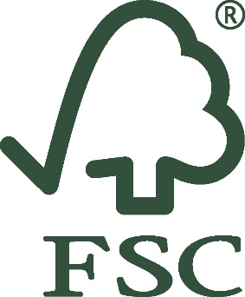

TABLE OF CONTENTS

I. Executive Summary 3
II. Project Governance 5
a. FSC Australia 5
b. FSC Australia’s Indigenous Engagement 6
c. Project Partners 7
III. Current Context of Northern Australian Forestry 8
IV. Current Context of East Arnhem Forestry 9
V. Summary of Partner Project 11
a. FSC Australia’s Role in the Project 12
b. The Continuous Improvement Procedure 13
c. Ecosystem Services Claims 14
VI. FSC Australia Project Phases - Overview 15
Phase 1 – Traditional Owner Engagement 16
Phase 2 – Gap Analysis 16
Phase 3 – Developing Market for Timber Products 17
Phase 4 – Conformance with Core Criteria and Developing Action Plan 17
Phase 5 – Main Audit (Initial Certification) 18
Phase 6 – Implementing Continuous Improvement Criteria 18
Phase 7 – Surveillance Audits 18
Phase 8 – Full Certification 19
VII. Partner Project Phases – Overview 20
Phase A – Forest Product Development Pilot 20
Phase B – Traditional Owner Engagement 21
Phase C – Forest Resource Assessment 22
Phase D – Indigenous Capacity Building 22
VIII. Budget 23
Cost Summary 23
Temporal Cost Distribution 24
Cost of Individual Project Phases 24
IX. Monitoring and Evaluation 26

- Executive Summary

Indigenous communities own, manage or have special rights to around 46Mha (an estimated 13Mha with commercial potential) of northern Australia’s 65Mha forest cover. Some of these forests currently support a small and socioeconomically important Indigenous commercial forestry and forest products industry. There is however a significant unrealised potential for further development of this culturally appropriate industry for remote northern Australian Indigenous communities with a potential to generate considerable and much-needed employment and production benefits.

In the Northern Territory’s East Arnhem Land, the Gumatj Traditional Owners own vast swathes of woodlands with a significant commercial potential, but the local communities remain among Australia’s and the world’s most socioeconomically disadvantaged and continue to experience limited availability of real jobs, low employment, and widespread poverty. Quality housing, healthcare and education infrastructure are lacking in the region, employment opportunities are limited, and the communities are largely welfare dependent. Further, many East Arnhem communities are considered socially dysfunctional and there is growing community concern about a decline in cultural knowledge and identity among the younger generations.

In East Arnhem Land there is however much optimism among community leaders who believe there is great potential for regional growth and prosperity. The abundance of natural resources, the region’s strong underlying traditional culture and its youthful energetic population are considered linked keys to unlocking the East Arnhem’s potential and enhancing community outcomes. The establishment of a sustainable forestry sector is expected to play a key role in this transformation.

The development of a sustainable, community and forest-based economy is consistent with the livelihood aspirations of many East Arnhem communities and could help mitigate some of these challenges by providing meaningful jobs and income, training and skills development, and create a job-ready workforce.

To unlock this potential, FSC Australia proposes a project that will offer real opportunities for Indigenous communities in northern Australia to enter into the mainstream market economy while simultaneously enabling a continuation or strengthening of customary livelihoods. FSC’s project will be a component of a fully funded $1,477,609 research for development project being delivered by the University of the Sunshine Coast. This partner project aims to empower the East Arnhem Traditional Owners to unlock the commercial potential of their forested land by providing their communities with a foundation for engaging in commercial forestry.
FSC Australia is an independent national office of FSC International. The world’s most trusted forest management certification scheme, FSC is an international not-for-profit, multi-stakeholder organisation that provides a market and performance-based certification program that drives environmentally appropriate, socially beneficial, and economically viable forest management.

The East Arnhem Traditional Owners hold deep physical and spiritual connections with their forest land as one component of their traditional ‘country’, and they have cultural obligations to ‘care for country’. Commercial forestry is however not part of their traditional knowledge and practices, so to ensure that the future holds positive and sustainable opportunities for present and emerging generations, the Traditional Owners wish to obtain FSC certification of their forestry operations as they are established through the partner project.

Certification under the rigorous standards of FSC provides a culturally appropriate market-based opportunity for participating communities to develop sustainable forest-based livelihoods while appreciating their enduring relationship with the land, water, fauna and flora, and their spiritual significance to cultural identify, traditional knowledge and livelihoods.

Achieving conformity with FSC’s comprehensive standards for forest management can however present a great challenge for Indigenous communities and large investment compared to the economic benefit that FSC certification can offer. In response, FSC has developed the so-called Continuous Improvement Procedure (CIP), which provides a framework designed to work for Indigenous communities in their contexts, while balancing their needs with the overall requirement to maintain the integrity of FSC certification.

A five-year process, CIP is an extension of FSC’s commitment to working with Indigenous peoples to find solutions for the responsible management of their forests. The procedure allows participating communities to be initially certified by FSC based on a subset of requirements of the applicable FSC forest management standard offering flexible steps towards conformity with the remaining requirements within a defined timeframe.

Thus, the procedure invites smallholders and communities to become part of the global FSC community of certificate holders without having perfect responsible management in place. Rather, it is enough to have initiated and implemented crucial measures and to commit to continue the path of sustainability by continuously improving forest management practices to ultimately conform with all requirements of the FSC standard

Applying this stepwise approach reduces the up-front activities and costs required from participating communities to access certification while providing the full suite of benefits of FSC certification from the outset. By the end of the process, the participating communities will be fully FSC certified and their forestry activities should be financially sustainable.

It is expected that the economic benefit of the FSC certification will allow the user of the CIP to cover its required investment for responsible forest management and FSC certification during the first certification cycle. Implementing this procedure will also facilitate the learning process necessary to conform with FSC requirements.

FSC Australia’s component of the project is slated to commence in late 2021 and will run for five years with the bulk of activities concentrated in the first 12 months. The total cost is AU$638,695 of which FSC International is expected to provide AU$153,000.

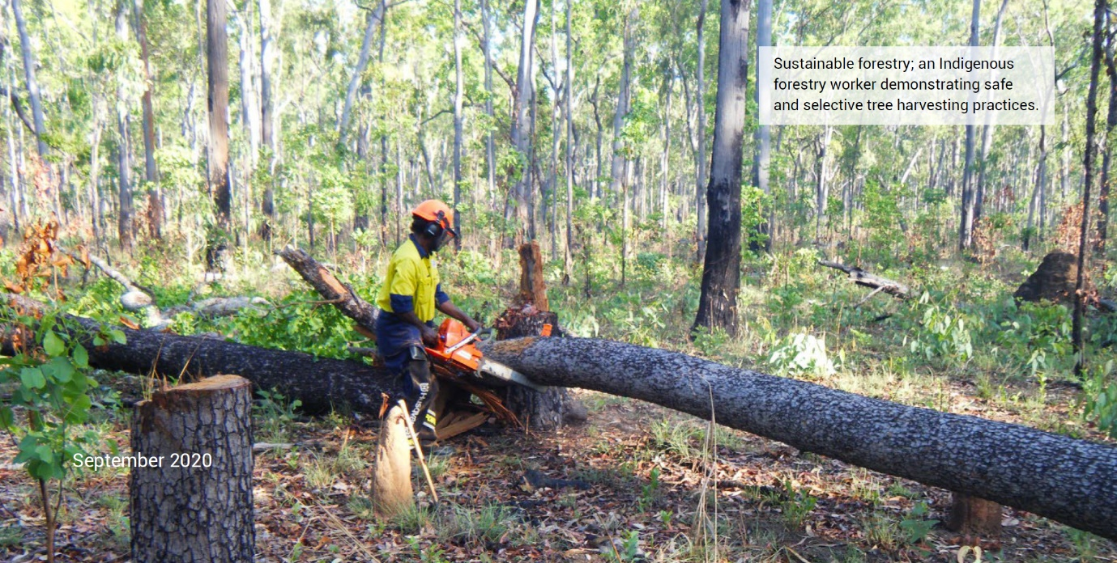
- Project Governance

FSC Australia

The Forest Stewardship Council (FSC) is a non-governmental, not-for-profit organisation that harnesses the power of the marketplace to promote the responsible management of the world’s forests by offering a voluntary, market-driven certification scheme. Established in 1993 as a response to concerns over global deforestation, FSC is a membership organisation with a governance structure based on participation, democracy, equity, and transparency. It is a unique forum where environmental, social, and economic stakeholders from around the world meet and, through consensus-based multi-stakeholder processes, define essential economic, social, and environmental criteria for forest management.

Through programs, services and solutions that support FSC certification, FSC empowers organisations, businesses and communities to take part in responsible forest management and supply chains. FSC uses certification to engage the market, driving recognition of the value of certified forest products to improve social and environmental practices in forests worldwide.

FSC has defined 10 principles with associated criteria that describe how forests must be managed to meet the social, economic, ecological, and cultural needs of present and future generations. These fundamental principles and criteria are realised in forests worldwide through FSC certification. To maintain the independence between operations seeking certification and FSC’s standards and requirements, FSC as the standard-setting body is not itself directly involved in the certification process; rather, FSC certification is carried out by auditors from independent, FSC accredited certification bodies.

The FSC labels can be found on millions of products around the world – from traditional wood and wood-based products like construction wood and printing paper to newer inventions like fibre-based clothing and car tyres made from natural rubber.

Today, more than 220 million hectares of forest are certified under FSC’s system, including more than 1.2 million hectares in Australia. Approximately 41,000 businesses, including 285 in Australia, in the supply chain are FSC certified.

Operating in Australia since 2001, FSC Australia is an independent National Office of FSC International. FSC Australia’s responsibilities include implementing a range of related programs in the region on behalf of FSC International as well as promoting responsible forest management by developing standards for forest management adapted to local circumstances in multi-stakeholder, consensus-based processes. FSC Australia also provides accurate policy, training, market support, and media liaison to grow the brand in Australia.
FSC Australia is an environmental charity with Deductible Gift Recipient (DGR) 1 status and is entitled to receive income tax deductible gifts and deductible contributions.

With limited resources FSC continues to develop and maintain its complex standards in Australia’s challenging environment for natural resource management across geographically disconnected and distinct regions. This is achieved through FSC Australia’s unique position as a multi-stakeholder organisation of diverse interests and experts, which enables FSC Australia to tap into its extensive network to access funding support, expertise, and collaborative partnerships.

FSC Australia’s ability to mobilise its own and others’ resources has been demonstrated with previous projects such as the development of the FSC Australia National Forest Stewardship Standard, FSC Australia’s standard for responsible forest management, which is the first Australian forest management standard that has built consensus across major economic, environmental, social stakeholders around the principles for responsible forest management in Australia.

FSC Australia members include some of Australia’s and the world’s leading environmental groups (for example, WWF, the Wilderness Society, and Greenpeace) as well as social organisations (for example, the Australian Manufacturing Workers' Union and the Institute of Foresters of Australia), businesses (for example, Visy, Asaleo Care, and Kimberly Clark), forest owners and managers, academics, campaigners, and individuals. Retailers like Woolworths, Coles, Aldi, Bunnings, Officeworks and Kmart have all entered into agreements with FSC Australia that permit them to use the FSC trademarks to advertise their FSC-certified products.

FSC Australia’s Indigenous Engagement

FSC Australia recognises that as the nation’s original stewards of the land, Aboriginal and Torres Strait Islander peoples have historically maintained the health of Australia’s forests, and continue to
perform this role through their unique knowledge of and continuing connection to lands, waters, and communities.

To ensure the spirit of FSC’s commitment to responsible forest management is upheld and authentically implemented, FSC Australia in 2015 convened an Indigenous Working Group (IWG) to guide and support its work. The IWG has absolute focus on ensuring Australia’s First Nation Peoples can benefit from the various components of the FSC system. To this end, the IWG has identified three existing community aspirations that align with FSC’s values:

- Increase Indigenous engagement in the management of Australia’s forests including the forest and wood products sector;
- Forest management that delivers economic, social, cultural, and environmental benefits to local First Nations Peoples’ communities; and
- Utilisation and transfer of traditional ecological and cultural knowledge from the old to the young.

The work of the IWG so far has focused on embedding and normalising the presence and work of the IWG as a vital, sustainable, and permanent part of FSC Australia’s work. Most notably, the IWG played an integral part in the development in FSC Australia’s first standard for forest management.

Building on this, the next phase of the IWG’s work will see the group taking part directly in place-based projects that have an impact for local communities and can provide learnings and demonstrations for projects elsewhere. The community aspirations identified above are a focal point in this process.

The IWG’s members comprise Indigenous leaders with a significant breadth of experience and connections that will help unlock the opportunities that FSC is uniquely able to create.

Project Partners

The project will be a component of a fully funded $1,477,609 research for development project being delivered by the University of the Sunshine Coast (USC) titled “Indigenous Commercial Forestry Opportunities: East Arnhem, Northern Australia”. The project commenced in late 2020 and is exploring the potential for commercial Indigenous forestry in the Northern Territory’s East Arnhem Land. The partner project aims to support the Traditional Owners to facilitate sustainable forest-based livelihoods and will provide the necessary insights to underpin the long-term viability of forestry in the area. This will empower the Traditional Owners to use their land in a way that supports their cultural practices while providing their communities with a sustainable foundation for economic growth and job opportunities.

The project is supported by the East Arnhem Forestry Working Group, which includes a range of East Arnhem regional stakeholders.

The project is being delivered by USC, with a number of partner entities led by Developing East Arnhem Limited (DEAL), an independent not-for-profit company established in 2014 that aims to drive economic development in East Arnhem, promoting the resilience of the region and opportunities for its people.

To deliver the project, USC and DEAL work with the Gumatj Corporation, the National Indigenous Australians Agency, Aboriginal land management organisations, a range of Northern Territory government bodies, and other Aboriginal workforce development organisations in the region.

Responsible for the project is Mark Annandale, Research Manager and Senior Research Fellow at USC. Mr Annandale specialises in sustainable development, the interface between Indigenous community development, community forestry and mining operations. An environmental scientist and community forestry specialist, Mr Annandale has extensive experience in developing environmental rehabilitation strategies with over 25 years’ experience in environmental management, community forestry, engaging with Indigenous people, cross-cultural communication, and cultural heritage management. The bulk of Mr Annandale’s work has been focussed on northern Australia.

Mr Annandale also provides technical input to FSC’s IWG and has been an FSC Australia Social Chamber Director since 2019. In addition, he was also part of the nine-person Standard Development Group that developed FSC Australia’s standard for forest management to which the participating communities’ operations will be certified.
- Current Context of Northern Australian Forestry

The Cooperative Research Centre for Developing Northern Australia (CRCNA) released the Northern Forestry and Forest Products Industry Situational Analysis in April 2020 identifying the enormous economic potential of the northern Australian forestry and forest products industry.

The analysis found that over the next five to ten years, there is scope for the northern Australian forestry and forest products industry to double or treble in output value to up to $300 million per annum based on sustainably increasing harvest levels, expansion of forest resources, and potential for downstream processing and value adding.

Further, the report highlighted that Indigenous engagement in native forest management for timber production has the potential to generate large employment and production benefits. For example, if 10% (~660,000 hectares) of the Indigenous-tenured private forest resource with commercial potential was actively managed for timber, this area could:

- generate $15 million in selectively harvested log income per annum, and
- produce $100 million worth of sawn timber annually, while
- creating around 370 direct jobs for Indigenous communities and industry partners.

In comparison, the combined forested area in the project area in East Arnhem Land is in excess of 800,000 hectares.

The savanna woodlands that cover large parts of Northern Australia, including much of East Arnhem Land, are primarily tall open eucalypt forests with a grassy understorey. Key canopy species include Eucalyptus tetrodonta (Darwin Stringybark), Corymbia nesophila (Melville Island bloodwood), and Erythrophleum chlorostachys (Cooktown ironwood). All three are high-quality timber species and have been demonstrated to be some of the hardest, densest and most durable timbers in the world. The woodlands provide critical habitat for numerous species of conservation significance, and other species with important kinship and totem values for local Indigenous people. The woodlands also contain many culturally important sites.

The savanna woodlands have long sustained the livelihoods of the local Indigenous people by providing vital resources, spiritual nourishment and other ecosystem services. Utilised resources include bushfoods (e.g. bushmeats, fruits, nuts, tubers, ‘sugarbag’ honey) and medicines, and materials for shelter, art and craft, and the manufacture of tools, weapons and canoes. Resource utilisation, ceremony and traditional fire are interwoven elements of the local Indigenous peoples’ ‘caring for country’ to maintain the woodlands’ biophysical and spiritual health and productivity.

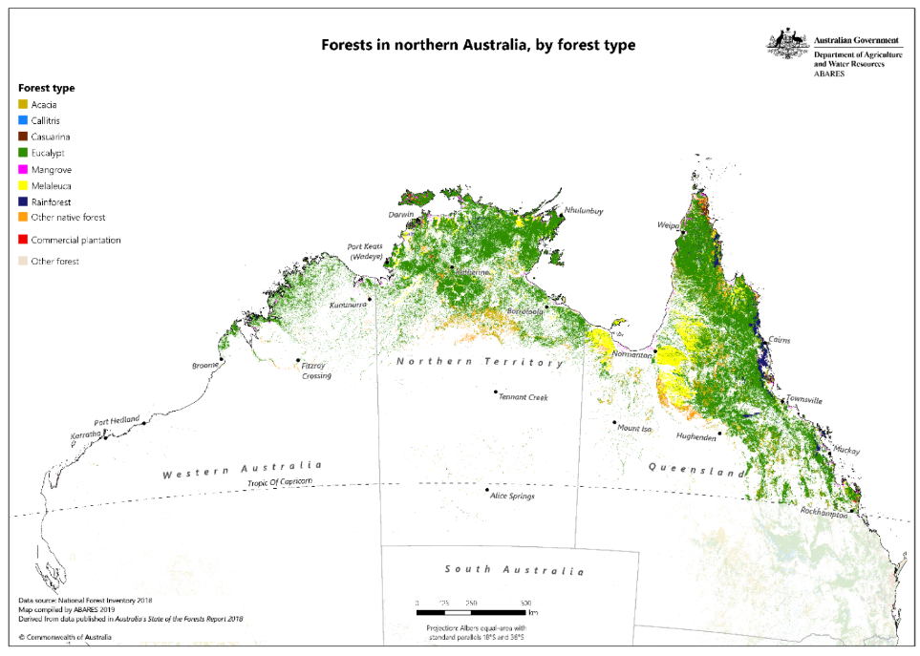
Figure xx: Forests in northern Australia by forest type (source: Australian Native Forest Commerciality)

- Current Context of East Arnhem Forestry

In the 2001 census, Australia’s Indigenous people comprised 2.4% of the population. Analysis of social data shows that as a group, Indigenous people in Australia do not fare well against most of the standard indicators of social and economic wellbeing. Often living on the fringes of mainstream society - both figuratively and physically - has meant that in many communities, especially in northern Australia, several generations within the same family have never been employed in or exposed to a market. Money comes from welfare or through government-funded programs perpetuating cycles of poverty, low self-esteem, low levels of education, unemployment, and the concomitant issues of substance abuse, domestic violence, and incarceration.

Fortunately, this gloomy picture can be counteracted by an abundance of success stories. Many Aboriginals and Torres Strait Islanders have achieved individual brilliance in a wide variety of pursuits, and Australia abounds with stories of community-based enterprises that have achieved social and commercial success.

In East Arnhem Land, there is much optimism among community leaders who believe there is great potential for regional growth and prosperity. The abundance of natural resources, the region’s strong underlying traditional culture and its youthful energetic population are considered linked keys to unlocking the region’s potential and enhancing social and economic community outcomes.

To nourish these outcomes, the Gumatj people have established the Gumatj Corporation, an Indigenous community development organisation, to invest their mining royalties in initiatives that support long-term employment, business, and sustainable development on the Gumatj homelands. An example of a successful, small-scale, Indigenous forestry business established by the Gumatj Corporation that is culturally, regionally, and strategically important is the Gumatj Sawmill and woodworks facility near East Arnhem’s service hub, Nhulunbuy that has been operating since 2008.

The mill sources high-value timbers (mainly Eucalyptus tetrodonta) from nearby mining leases processing around 1,500 m3 of sawlogs per annum into a range of sawnwood and other value-added products for local and regional markets. The operation employs around eight Gumatj people full-time and other seasonal/casual workers as required.
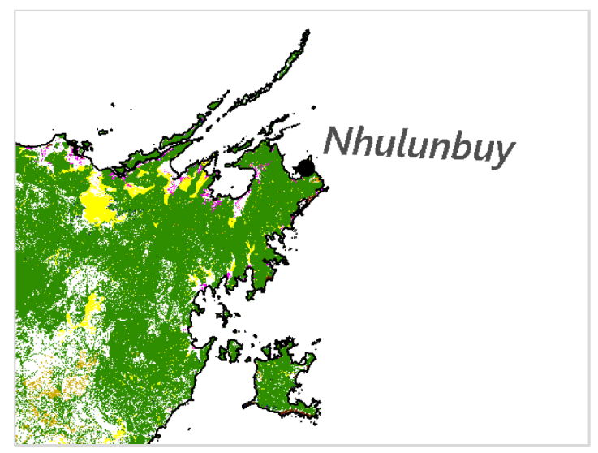
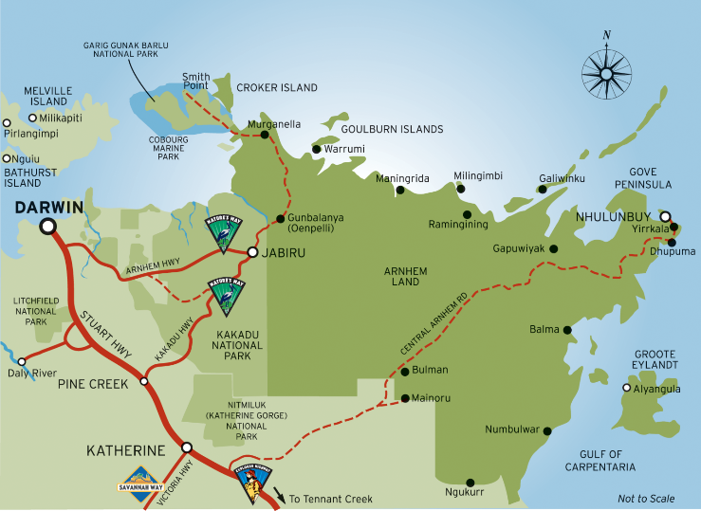
Figure xx (left): Map of East Arnhem Land
Figure xx (right): Native eucalypt forest in East Arnhem Land. Shaded green areas indicate native eucalyptus open forest coverage.

The impetus for the business was the opportunity to train and employ Gumatj people and supply local timbers for improved local housing and other construction. As the operation has grown, value-added products have included roof trusses, decking and other speciality products for prominent
Northern Territory Government projects in Darwin. Materials are also supplied to a regional Indigenous furniture business (Manapan Furniture) that manufactures custom-made, high-end designs. The Gumatj Sawmill and its Indigenous staff are thriving; this is due to supportive partnerships with government and private industry but also because of the drive of the local Gumatj people who want to engage with an industry that matches their cultural identity, to be skilled-up, and to have increased confidence and work-readiness for other forestry or mainstream career paths.

There is much opportunity for the Gumatj Sawmill to maintain, diversify, and expand its operations into the future to maximise positive outcomes. Key goals are to increase Indigenous employment and reduce the region’s need for expensive timber imports. The CRCNA report mentioned previously, for example, found that the Gumatj Sawmill has potential to expand its current output and product range. The report also highlighted that the Gumatj Sawmill could be a model for other communities in the region to learn from to develop forestry activities in support of sustainable regional economic development (p. 31).

Rio Tinto who owns the mining leases the Gumatj Sawmill currently sources most of its timber from, has however announced that it will cease its East Arnhem mining activities by 2030, which will reduce the sawmill’s timber supply dramatically. This comes on top of Rio Tinto’s 2013 decision to close its alumina refinery in Nhulunbuy, with the loss of 1,100 jobs, or almost 25%, of the town’s population. Developments that threaten to exacerbate the socioeconomic disadvantages that are already a defining feature of East Arnhem Land’s Indigenous communities.

Indigenous-led sustainable forestry has been identified as a potential key component of the region’s economic rebound as it can provide East Arnhem communities a long-term sustainable source of timber and income from their vast forest resource.

On this backdrop, FSC Australia’s partner project will engage with the Gumatj to build the capacity for commercial forestry and provide the evidence-based knowledge they need to unlock the commercial potential of their forested land.

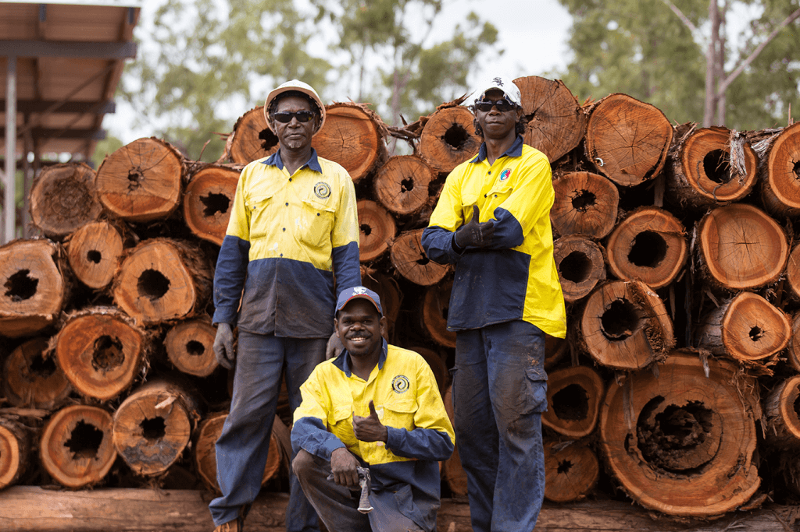
Figure xx (left): East Arnhem building constructed with Darwin stringybark roof trusses from the Gumatj Sawmill
Figure xx (right): Gumatj sawmill staff in front of Darwin stringybark (Eucalyptus tetrodonta)

- Summary of Partner Project

It is known that some East Arnhem Indigenous communities and businesses are interested in Indigenous-led forest and timber product enterprises, and that the region contains vast areas (~3.3 Mha) of Indigenous-owned native forests with commercial potential. These forests are primarily found on Indigenous freehold lands suited for long-term, selective, and sustainable low-impact harvesting.

Current best-available data strongly suggests these forests have commercial value; the data is however coarse and not ground-truthed, hiding the true commercial potential (e.g. productivity and product mixes) of East Arnhem’s forests. This is limiting the ability to forecast end-product types, harvestable quantities/values and broader market, and supply chain opportunities for the region. In addition, the Indigenous communities with interest in commercial forestry are largely lacking in business experience and have expressed a need to develop procedures to ensure their forest resource is harvested sustainably.

FSC Australia’s project partners, led by the USC, will help address the forest data shortfalls, build capacity, and align new forest product development with forest productivity and Indigenous community capacity to enable the Traditional Owners to make an informed decision about engaging in commercial forestry.

The project partners and the Gumatj people have identified a harvesting demonstration site located 150 kilometres southwest of Nhulunbuy where the Gumatj Traditional Owners know their forest country well and want to demonstrate to other East Arnhem communities what sustainable forestry looks like.

At this demonstration site, the project partners will build interested communities’ capacity for commercial harvesting (e.g. identification of trees for harvesting and harvesting techniques) and provide knowledge and information about commercial forestry.

Simultaneously, the project partners will develop an inventory of the East Arnhem forests to map resources with commercial potential and explore the market to determine if it will be commercially viable to harvest the timber and get it to market. The project will also send logs collected from the site to a research mill in Brisbane to better understand the characteristics of the timber and its potential, which will help determine what the timber can be used for as well as the commercial value of the output from the Gumatj Sawmill.

The native eucalypt species common in the area are known to be some of the hardest, densest, and most durable timbers in the world, and the commercial potential of East Arnhem’s forest estate is consequently significant. The partner project will help determine how significant.

Based on the forest inventory, the understanding of the commercial potential of their forests, and the capacity building provided at the demonstration site, the Traditional Owners will have evidence-based knowledge to empower them to determine the pace and kind of forestry that occurs on their land, and to control whether forestry takes place at all.

FSC Australia’s Role in the Project

The majority of Australia’s Indigenous communities aspire to economic independence as a way of overcoming poverty, but they also want to maintain their cultural traditions, including looking after the land. The enduring influences of customary law, kinship responsibilities, and obligations to care for the environment and sacred places must be factored into any project that aims to support economic development in an Indigenous context in Australia.

This is also the case in East Arnhem where the Traditional Owners have expressed an interest in obtaining FSC-certification of their forestry operations as they are developed through the partner project to ensure a continuation of customary beliefs and values. FSC certification will enable the Traditional Owners to build a forest-based economy underpinned by FSC standard for forest management, which will help the them ensure that forestry practices respect ecological limits, values, people, and culture.

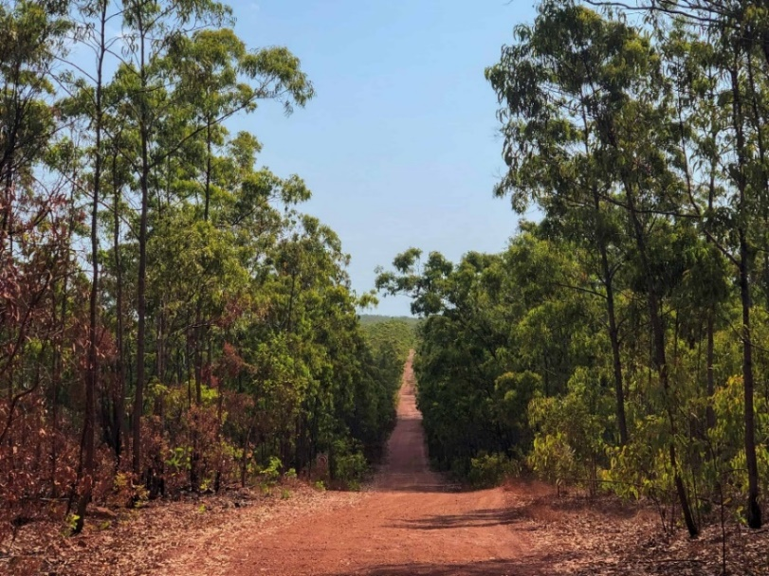
As the world’s most trusted label for responsible forest management, FSC certification could also provide increased access to market and a premium for the forest products from the project. Public opinion polls, for example, consistently report that consumers will preference and pay more for products that are shown to be from responsibly managed forests.

Those communities that express interest in FSC-certified commercial forestry will be organised in a so-called ‘group certificate’. Group certificates allow several forest management units to join together and form a group under one FSC certificate. This streamlines tasks, alleviates the administrative burden, reduces costs thanks to the economy of scale, and is the main tool used in FSC certification of small forest properties.

The exact number of communities and the size of the forested area that will become certified under the group certificate is not yet known as the project partners are still in the process of establishing the harvesting demonstration site and showcasing to adjacent communities what responsible forestry looks like.

Based on current indications, it is however expected that there will be significant interest in the project, and it is consequently estimated that a number of communities with many thousand hectares of forested land will join the project. It is also expected that the successful establishment of FSC-certified commercial forestry activities and the benefits that flow from this will inspire adjacent communities over time to join the group certificate. This could see the project grow significantly over time.

The Continuous Improvement Procedure

During its 27 years of operation, FSC has learnt that one size does not fit all; large and well-established forest corporations and Indigenous communities, for example, need different support services and tools to achieve certification. It is known that Indigenous communities often find
FSC’s policies and standards too complex to understand and too challenging to implement on the ground. With smallholders and Indigenous communities owning or managing a modest five per cent of the more than 220 million hectares of FSC-certified forests worldwide, addressing this underrepresentation is one of the main challenges for FSC at this stage in its history.

To invigorate certification to drive the spread of responsible forest stewardship on Indigenous-tenured land, and land owned by smallholders across the world, FSC has developed the CIP, which removes many of the barriers to certification smallholders and communities typically experience and promises to make certified forestry an attractive, accessible and viable land-use option. The procedure will be published in March 2022 and the East Arnhem project will likely be the first time it is implemented anywhere in the world. As such, the project will also provide valuable lessons for other Indigenous communities in Australia and beyond.

The procedure allows participating communities to be initially certified based only on a subset of requirements of the applicable FSC forest management standard, offering flexible steps towards conformity with the remaining requirements within a defined timeframe. It does this by distinguishing between Core, Continuous Improvement and elecleon Criteria that shall be conformed with in different points in time. The CIP user shall meet the Core Criteria and have an Action Plan to obtain FSC certification at the initial stage of the process. To maintain certification, the Continuous Improvement Criteria and Chameleon Criteria shall be met in accordance with the path established in the Action Plan.

In sum, the three groups of criteria are:

- Core Criteria that forest managers must conform with to obtain certification;
- Continuous Improvement Criteria that are expected to be achieved in a progressive manner over five years; and
- Chameleon Criteria that become activated under certain circumstances and otherwise must be achieved by the end of the five-year implementation phase.

The main difference to the conventional pathway to obtaining FSC certification is that the East Arnhem communities will attain certification and all the benefits that flow from it up front when conformance with the Core Criteria is achieved, whereas the traditional pathway to certification rests on conformance with the full suite of criteria of the applicable standard. Applying this stepwise approach will reduce the up-front activities and costs required from communities to access certification while providing access to the benefits of full FSC certification from the outset.

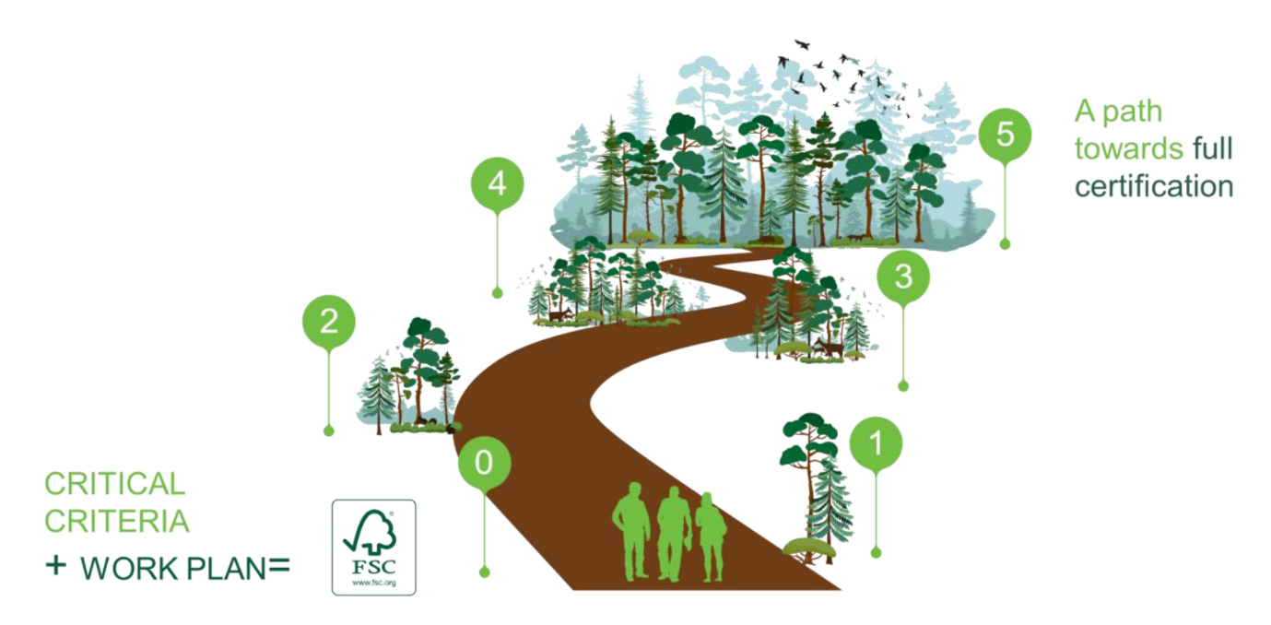
Figure xx: The path to be taken by Indigenous communities as users of the CIP towards full conformity with forest management standards.

Ecosystem Services Claims

Forests provide society with a wide range of benefits, from reliable flows of clean water to productive soil and carbon sequestration. These benefits are collectively known as ecosystem services. In 2018 FSC introduced the Ecosystem Services Procedure, which builds on FSC forest management certification by allowing forest managers and owners to make specific, credible and third-party verified claims about how their management activities are contributing to maintaining and/or enhancing various ecosystem services in their forests. The aim of the procedure is to bring additional monetary and non-monetary benefits to those who actively support the responsible management of the world’s forests and ecosystem services. Impacts can be verified for five types of ecosystem services:

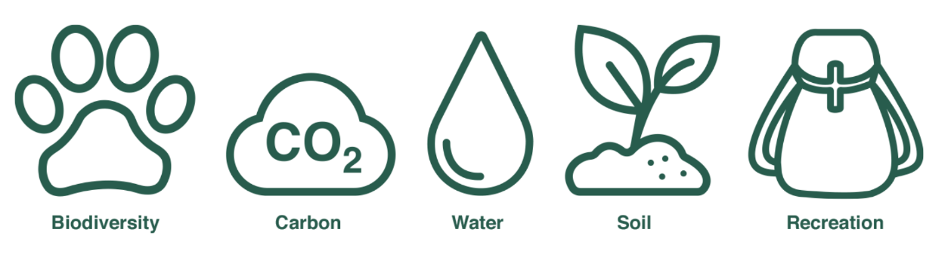

Only forests that are covered by FSC forest management certification are eligible for ecosystem service impact verification under the FSC Ecosystem Service Procedure. The verification process is undertaken by the same certification body as for forest management certification. It can take place at the same time as forest management audits.

Impacts can be verified for one or any combination of the five ecosystem services, dependent on the services of interest for promotion or investment. As FSC forest management standards provide adequate social and environmental safeguards, it is acceptable to verify positive impacts only for the ecosystem services of interest; conformance with the standards ensures forest managers are not degrading the others.

In the project, those areas of the participating communities’ forest estate that are not managed for timber production due to commercial, cultural, or environmental factors will have some or all of these ecosystem services verified, where they exist, under the FSC Ecosystem Services Procedure. This will ensure an ongoing income from non-productive forest areas and an additional ongoing incentive to manage them to restore and/or maintain ecosystem system services that are present.

Australian businesses are increasingly searching for ways to demonstrate the positive impact their products and investments have on the world’s ecosystems, including carbon offsetting. Here verified positive impacts from FSC-certified forests offer a new way for businesses to actively support forest managers to protect ecosystem services and to share the positive impacts of their investments to customers, staff, and shareholders. On the backdrop, and based on conversations with potential investors and inspiration from similar payment for ecosystem services projects in the region, it is expected that there will be a strong a favourable market for the verified impacts from the East Arnhem communities verified claims.

Verified impacts are included in the forest management certification process outlined below and are consequently not mentioned explicitly but can rather be considered a part of the certification process.

- FSC Australia Project Phases - Overview

There are eight distinct and at times concurrent phases of FSC Australia’s component of the project. The different phases of the project and their start and end dates are presented in Figure xx.

Phase | Task Name | Start Date | End Date | - | - | - | - | - | - | - | - | - | 2023 | 2024 | 2025 | 2026 | 2027
1 | Traditional Owner Engagement | - | -
2 | Gap Analysis | - | -
3 | Developing Market | - | -
4 | Conformance with Core Criteria/Develop Action Plan | - | -
5 | Main Audit (initial certification) | - | -
6 | Implement Continuous Improvement Criteria | 2022 | 2027
7 | Surveillance Audits | 2023 | 2026
8 | Full Certification | 2027 | 2027
Figure xx: Start and finish dates for project phases

Phase 1 – Traditional Owner Engagement

Summary
Traditional Owner engagement, involving consulting with the participating communities and informing them of the CIP as well as the opportunities and practicalities of FSC certification.

Key deliverables and timing
FSC IWG members will consult with the participating communities to build their knowledge of FSC certification and inform them about associated costs and potential benefits. FSC staff and a consultant engaged by FSC Australia will provide technical input to the IWG’s engagement with the Traditional Owners.

- [date] to [date] – engagement with the participating communities.

Phase 2 – Gap Analysis

Summary
To identify areas where the participating communities must implement new measures and procedures to conform with the Core Criteria, a so-called gap analysis will be undertaken by the consultant.

To avoid conflicts of interest, FSC Australia and the auditor who will undertake the audit against the FSC standard are not permitted to undertake the gap analysis.

Key deliverables and timing
There are significant overlaps between FSC’s forest management standard and legislative federal and state requirements, which will be implemented by the project partners as they assist the participating communities establish their harvesting activities. The gap analysis will provide a report that identifies additional improvements and verifiers the participating communities must implement to achieve conformance with the Core Criteria. The fieldwork required for the gap analysis will take place alongside and following the Traditional Owner engagement in Phase 2.

- [date] – a comprehensive report produced by the consultant with clear identification of gaps (i.e. likely non-conformities) and recommendations of implementable solutions.

Phase 3 – Developing Market for Timber Products

Summary
The project partners are currently working with governments to ensure locally produced timber is used in government-funded housing in the area. Moreover, the partner project has allocated $100,000 to undertake a forest product development pilot, involving a harvesting, product identification, manufacturing, performance testing, and market assessment pilot.

Throughout the project, FSC Australia will use the information from the forest product development pilot to work with its extensive network of wholesalers and retailers to ensure a continued demand for FSC-certified products from the project that are not sold into the local market. Major retailers have already expressed a keen interest in the products from the project. This work will involve meetings with timber buyers in the supply chain, building companies, and architects as well as visits to East Arnhem by FSC Australia Communication Manager to develop stories and images from the project.

Key deliverables and timing

- Ongoing from [date] – FSC Australia activates its network to ensure a continued demand for the timber products from the project.

Phase 4 – Conformance with Core Criteria and Developing Action Plan

Summary
Based on the gap analysis, the consultant will work with the participating communities to achieve conformance with the Core Criteria. The FSC IWG will take part in this process to ensure measures are implemented in a culturally appropriate and sensitive manner and with free, prior and informed consent.

It is a requirement under the CIP that the participating communities develop an action plan that details how the remaining criteria (i.e. the ‘Continuous Improvement Criteria’) will be implemented. The consultant will, with input from the IWG, work with the participating communities to develop this action plan.

Key deliverables and timing
Gaps identified in the gap analysis are closed and an action plan developed to prepare for FSC certification.

- [date] to [date] – consultant and the IWG work with the participating communities to implement measures recommended in the gap analysis to achieve conformance with the Core Criteria.
- [date] to [date] – consultant and IWG work with the participating communities to develop the action plan.

Phase 5 – Main Audit (Initial Certification)

Summary
An FSC certificate is issued following confirmation of conformance with the Core Criteria by an independent FSC accredited auditor. Being a pilot project, the audit and its associated audit report will require more time than traditional audits.

The auditor is required to establish an interdisciplinary audit team with one or more experts that complement the auditor’s knowledge. It is expected that two experts in East Arnhem Aboriginal culture and ecology respectively will be included in the audit team. Evidence of conformance is collected on the ground and presented in the audit report by the auditor.

The FSC IWG will assist the auditor in assembling the audit team and provide cultural awareness training of the team as required.

Key deliverables and timing
The auditor and the two experts assess conformance of the participating communities’ forestry operation with the Core Criteria on the ground in East Arnhem Land.

- By [date] – cultural awareness training of the audit team.
- By [date] – auditor and experts undertake the on-ground part of audit.
- By [date] – audit report finalised and certificate issued.

Phase 6 – Implementing Continuous Improvement Criteria

Summary
Continuous Improvement Criteria are introduced annually. The consultant and the FSC IWG will work with the participating communities to implement Continuous Improvement Criteria prior to audits.

Key deliverables and timing
In accordance with the action plan developed in Phase 5, the participating communities, assisted by the consultant and the IWG, implement Continuous Improvement Criteria as they are gradually introduced.

- By [date] 2023 – Continuous Improvement Criteria implemented.
- By [date] 2024 – Continuous Improvement Criteria implemented.
- By [date] 2025 – Continuous Improvement Criteria implemented.
- By [date] 2026 – Continuous Improvement Criteria implemented.
- By [date] 2027 – Continuous Improvement Criteria implemented.

Phase 7 – Surveillance Audits

Summary
Organisations certified by FSC undergo annual surveillance audits to assess their continued conformance with applicable standards. Surveillance audits are typically not as comprehensive as main audits. For the participating communities, the surveillance audit will assess conformance with the Core Criteria as well as the Continuous Improvement Criteria that have been introduced.

Key deliverables and timing
Auditor conducts field assessment to confirm the participating communities’ continued conformance with the Core Criteria and introduced Continuous Improvement Criteria. Experts will participate as required.

- By [date] 2023 – surveillance audit and mandatory audit report completed assessing conformance with Core Criteria and introduced Continuous Improvement Criteria.
- By [date] 2024 – surveillance audit and mandatory audit report completed assessing conformance with Core Criteria and introduced Continuous Improvement Criteria.
- By [date] 2025 – surveillance audit and mandatory audit report completed assessing conformance with Core Criteria and introduced Continuous Improvement Criteria.
- By [date] 2026 – surveillance audit and mandatory audit report completed assessing conformance with Core Criteria and introduced Continuous Improvement Criteria.

Phase 8 – Full Certification

Summary
By the end of the Continuous Improvement certification cycle, the participating communities will, following the gradual implementation of Continuous Improvement Criteria, be in conformance with FSC’s forest management standard in its entirety. Their conformance will be confirmed in a main audit and a new five-year certificate issued.

This marks the end of the Continuous Improvement certification cycle and the certificate will be issued on the same terms as other FSC certificates.

Key deliverables and timing

A main audit is conducted by the auditor and relevant experts to confirm conformance with FSC’s forest management standard in its entirety.

- By [date] 2027 – main audit against the full FSC standard for forest management conducted and a new five-year certificate issued.

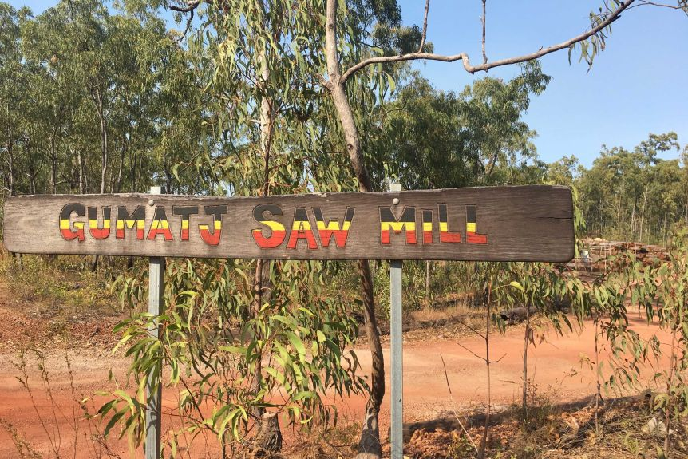

Figure xx: The Gumatj sawmill
- Partner Project Phases – Overview

There are four concurrent phases of the responsible forestry research for development partner project managed and delivered by USC. The phases of the FSC component of the project will be integrated into the overarching partner project when funding has been secured. The phases of the partner project are:

Phase A – Forest Product Development Pilot

Summary

Forest product development pilot, involving a harvesting, product identification, manufacturing, performance testing, and market assessment pilot.

Key deliverables and timing

The completion of a harvesting and marketing pilot to identify, manufacture and market-test value-added timber products from logs sourced from East Arnhem native Indigenous-owned forests:

• By December 2020 - Establish the Gumatj harvesting demonstration site - i.e. define the site, commence training including tree marking, production identification, species mix and other harvesting requirements. Timing to commence harvest operations determined by Gumatj sawmill operational availability and any COVID-19 restrictions.

• By April 2021 - Prepare an Operational Harvest Plan (OHP) during the 2020/21 wet season for the harvested area that will ensure all operations are consistent with FSC’s forestry standard for Group Certification.

• Dry season 2021 - Implement the harvest trial adhering to the Traditional Owner endorsed OHP supported by CALM training program.

• Ongoing through 2021 - Supply logs to the Gumatj sawmill and a shipment of logs (as billets) to QDAF Salisbury Research Facility (Brisbane).

• By February 2022 – initial timber characteristic and product development report;
• By February 2022 – initial market assessment report which includes information gathered from surveys of timber merchants regarding their perceptions of/experiences with sample products;
• Continuous feedback on outcomes will be received through 2021.

• From project commencement to December 2022 - Forest inventory of the ~200 ha area identified for harvesting. This includes assessment of the forest productivity and product mix, plus the local Indigenous traditional values and uses (including fire management) of the forest. The inventory will also utilise a newly developed inventory app for mobile phones.

Phase B – Traditional Owner Engagement

Summary

Traditional Owner engagement with adjacent communities, involving consulting with Indigenous communities interested in commercial forestry and informing them of industry opportunities and practicalities.

Key deliverables and timing

In areas identified to have commercial forestry potential, DEAL will consult with adjacent Traditional Owners and communities to gauge their interest in forestry, discuss commercial opportunities, and explain the practicalities of forestry on country and the associated costs and potential benefits:

• By August 2021 - Identify needs for further engagement with Traditional Owners and communities to grow understanding of forestry, including Mark Annandale and USC and DEAL staff undertaking additional engagement work where required.

• By December 2021 - Overlaying forest resource maps with areas where Traditional Owners confirm identified forestry development may occur and confirm scale and scope of forestry development. This will include mapping and documentation of each interested community’s opportunities and challenges for forestry development.

The project will also look to schedule early engagement with any interested parties and communities on this project.

Phase C – Forest Resource Assessment

Summary
Forest Resource Assessment, involving a comprehensive inventory (desktop analysis and field-based surveys) of the commercial forests of East Arnhem Land.

Key deliverables and timing
Fine-scale mapping/reporting of the forests of east Arnhem Land and their commercial potential, and development of simple but credible forest assessment tools. These tools can be utilised by the local Indigenous communities to undertake inventories of their forests to collect and document data on forest productivity and Indigenous traditional values/uses:

• From project commencement to December 2022 - Collation of existing data on forest resources across the east Arnhem region to identify areas with commercial potential.

• Mid 2021 – preliminary indicative data based on previous work and 2020 and 2021 data collection.

• From project commencement to December 2022 - Field inventory in identified priority areas (from Phase 2) with commercial forestry potential.

• Collation of inventory data (forest productivity and product mix and traditional forest values/usage) into community-level reports.

• Rolling updates on assessment of data collected will be provided throughout the project to build the picture of regional forest resources over the life of the project.

Phase D – Indigenous Capacity Building

Summary
Indigenous Capacity Building, involving working with the Indigenous communities with identified potential to operate forestry enterprises to develop their forestry workforce and business opportunities. The project’s multiple outputs will benefit East Arnhem Indigenous communities in sustainable development of their forest resources for long-term community livelihood benefits. The results will also be translatable to other parts of northern Australia where there is potential for FSC-certified Indigenous forestry.

Key deliverables and timing
Traditional Owners trained in technical forestry operations, manufacturing of forest products to expand on the current Gumatj sawmilling business, and linking communities with prospective product purchasers and partners/investors and other Indigenous forestry businesses engaged in product development and marketing:

• By December 2022 - Prepare an integrated forestry development model, identifying how communities can work together across the forestry industry.
• By May 2023 - Training community members in forest resource assessment;
• Ongoing - Facilitate relationships/partnerships between local Indigenous communities with commercial forestry potential and regional commercial forestry businesses and other potential partners, investors, and Indigenous forestry collaborators for sharing of harvesting, marketing, and business management experiences.
- Budget

The project partners’ engagement is fully funded with significant co-financing from the participating partners combined with funding from external sources:

Source | Cash (AUD)
Forest and Wood Products Australia | 310,000
University of the Sunshine Coast | 117,800
Gumatj Corporation | 90,000
Developing East Arnhem Limited (DEAL) | 60,000
National Indigenous Australians Agency (NIAA) | 60,000
Northern Territory Department of Chief Minister and Cabinet (DCM&C) | 55,000
Northern Territory Department Industry, Tourism and Trade (DIIT) | 45,000
TOTAL | 737,800*

*In-kind contributions from funders are not tabled but include approx. $739,809 of value add (total investment $1,477,609)

Cost Summary

FSC Australia proposes a total cost of $638,695, distributed as outlined below. The cost of the individual phases of the project is broken down further on the following pages.

Phase | Cost element | Total estimated cost (AUD)
1 | Traditional Owner engagement | 32,650
2 | Gap analysis | 29,560
3 | Developing Market for Timber Products | 31,500
4 | Conformance with Core Criteria and Developing Action Plan | 36,950
5 | Main audit (initial certification) | 36,850
6 | Implementing Continuous Improvement criteria | 102,125
7 | Surveillance audits | 56,300
8 | Main audit (full certification) | 34,850
 | Subtotal | 360,785
 | USC support and facilitation* | 120,000
 | Subtotal | 480,785
 | Contingency (20%)** | 96,157
 | Subtotal | 576,942
 | Administration (10%) | 57,694
 | TOTAL | $634,636***

* For the life of the project, $20,000 per annum has been factored in to cover the extra workload USC will be required to undertake to support and facilitate the inclusion of the FSC component into the partner project. The partner project was not designed to encompass FSC-certification, and there will consequently be an ongoing need for USC to ensure the projects stay aligned. Additionally, USC’s capacity building for forestry will be more extensive as it has to factor in the requirements of the FSC forest management standard.
** The incorporation of contingency into the total project cost covers events that are not accounted for in the cost estimate; for example additional work required to implement Critical and Continuous Improvement Criteria; remediation work required if the participating communities and found not to be conforming with the introduced criteria; and days lost in the field to sickness or inclement weather. The contingency has purposely been set relatively high (20%) due to the unique nature of the project; being a pilot project delivered in an Indigenous community that has had limited prior exposure to commercial forestry will create unforeseen costs.
*** In-kind contributions from the participating communities for accommodation amount to approx. $40,065 (not tabled).

Temporal Cost Distribution

The following table presents the distribution of costs per annum across the duration of the project.
Phase/ year | Phase 1 | Phase 2 | Phase 3 | Phase 4 | Phase 5 | Phase 6 | Phase 7 | Phase 8 | Subtotal | Total, incl. USC support, contingency and administration
2021 | 32,650 | 29,560 |  |  |  |  |  |  | 62,210 | 108,517
2022 |  |  | 5,250 | 36,950 | 36,850 |  |  |  | 79,050 | 130,746
2023 |  |  | 5,250 |  |  | 20,425 | 14,075 |  | 39,750 | 78,870
2024 |  |  | 5,250 |  |  | 20,425 | 14,075 |  | 39,750 | 78,870
2025 |  |  | 5,250 |  |  | 20,425 | 14,075 |  | 39,750 | 78,870
2026 |  |  | 5,250 |  |  | 20,425 | 14,075 |  | 39,750 | 78,870
2027 |  |  | 5,250 |  |  | 20,425 |  | 34,850 | 60,525 | 79,893
 |  |  |  |  |  |  |  |  | $360,785 | $634,636

Cost of Individual Project Phases

The tables below provide a further breakdown of the budget into the individual phases of the project.

Phase 1: Traditional Owner engagement
Cost element  - units/persons in brackets | Cost per day | Days | Total estimated cost (AUD)
Travel (4) | - | - | 3,200
Transportation | 145 | 10 | 1,450
Consultant (1) | 500 | 10 | 5,000
IWG members (2) | 500 | 10 | 10,000
FSC staff (1) | 500 | 10 | 5,000
Traditional Owner guides (4) | 200 | 10 | 8,000
 |  |  | 32,650

Phase 2: Gap analysis
Cost element  - units/persons in brackets | Cost per day | Days | Total estimated cost (AUD)
Transportation | 145 | 8 | 1,160
Consultant (1) | 500 | 15 | 10,000
IWG members (2) | 500 | 8 | 8,000
FSC staff (1) | 500 | 8 | 4,000
Traditional Owner guides (4) | 200 | 8 | 6,400
 |  |  | 29,560

Phase 3: Developing market for timber products – repeated in year 1, 2, 3, 4 and 5
Cost element  - units/persons in brackets | Cost per day | Days | Total estimated cost (AUD)
Travel | - | - | 1,200
Transportation and accommodation | 350 | 3 | 1,050
FSC staff | 500 | 6 | 3,000
Cost per year |  |  | 5,250
Cost full certification cycle |  |  | 31,500

Phase 4: Conformance with Core Criteria and Developing action plan
Cost element  - units/persons in brackets | Cost per day | Days | Total estimated cost (AUD)
Travel | - | - | 800
Transportation | 145 | 10 | 7,650
Consultant (1) | 500 | 25 | 12,500
IWG members (2) | 500 | 10 | 10,000
Traditional Owner guides (3) | 200 | 10 | 6,000
 |  |  | 36,950

Phase 5: Main audit (initial certification)
Cost element  - units/persons in brackets | Cost per day | Days | Total estimated cost (AUD)
Travel (3) | - | - | 2,400
Transportation | 145 | 10 | 1,450
Auditor (1) | 750 | 16 | 12,000
Experts (2) | 750 | 10 | 15,000
Traditional Owner guides (3) | 200 | 10 | 6,000
 |  |  | 36,850

Phase 6: Implementing Continuous Improvement Criteria – repeated in year 1, 2, 3, 4 and 5
Cost element  - units/persons in brackets | Cost per day | Days | Total estimated cost (AUD)
Travel (4) | - | - | 3,200
Transportation | 145 | 5 | 725
Consultant (1) | 500 | 10 | 5,000
IWG members (2) | 500 | 5 | 5,000
FSC staff (1) | 500 | 5 | 2,500
Traditional Owner guides (4) | 200 | 5 | 4,000
Cost per year |  |  | 20,425
Cost full certification cycle |  |  | 102,125

Phase 7: Surveillance audits – repeated in year 2, 3, 4 and 5
Cost element  - units/persons in brackets | Cost per day | Days | Total estimated cost (AUD)
Travel (2) | - | - | 1,600
Transportation | 145 | 5 | 725
Auditor (1) | 750 | 8 | 6,000
Expert (1) | 750 | 5 | 3,750
Traditional Owner guides (2) | 200 | 5 | 2,000
Cost per year |  |  | 14,075
Cost full certification cycle |  |  | 56,300

Phase 8: Main audit (full certification)
Cost element  - units/persons in brackets | Cost per day | Days | Total estimated cost (AUD)
Travel (3) | - | - | 2,400
Transportation | 145 | 10 | 1,450
Auditor (1) | 750 | 16 | 12,000
Experts (2) | 750 | 10 | 15,000
Traditional Owner guides (3) | 200 | 10 | 6,000
 |  |  | 34,850

- Monitoring and Evaluation

Embedded into FSC’s normative procedures for assessing certificate holders’ continued conformance with applicable standards, the project’s progress and performance will be assessed by the independent auditor on an annual basis during the main and surveillance audits.

As such, the Phase 2 gap analysis will provide a baseline to measure performance against, while the main audit (initial certification) in Phase 5, will confirm the implementation of the CIP’s Core Criteria and the development of a credible plan for implementing the Continuous Improvement Criteria. The following annual surveillance audits will confirm conformance with the newly introduced Continuous Improvement Criteria and the criteria that have already been introduced.

The audit reports provide a comprehensive unbiased and methodical assessment of whether activities occur as planned and that they remain directed towards the project’s stated objectives. So-called Corrective Action Requests, issued by the auditor if non-conformance is identified, must be closed within a set timeframe, which ensures appropriate action is taken if the project deviates from the action plan developed in Phase 4.

Finally, the main audit (full certification) taking place in year six of the project will confirm conformance with the full suite of criteria of the FSC forest management standard.

As is the case with all forest management audits in the FSC system, substantial audit report summaries from the project’s main and surveillance audits will be made publicly available on the FSC Public Certificate Search. The public availability of audit report summaries ensures full transparency and provides an opportunity to track the progress of the project as it implemented.

In addition, the pilot project is expected to become the subject of a series of academic papers co-authored by two USC academics (including Mr Annandale) and other project partners, including FSC Australia’s Policy and Standards Manager. A proposal for a paper has been approved by the academic journal Small-scale Forestry for its upcoming special issue on forest certification. These peer-reviewed papers will track the progress of the pilot test over its lifespan and provide an extra layer of monitoring and evaluation.

When the project has been delivered, it will be fully evaluated FSC International and FSC Australia with input from project stakeholders to refine the CIP further before it is decided if it should be rolled out globally.

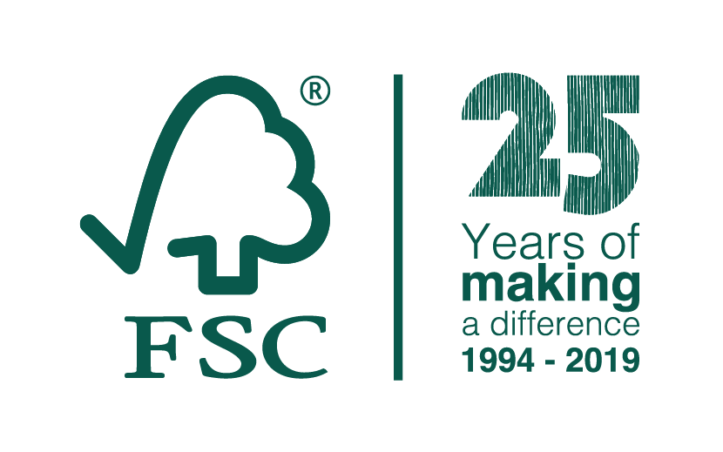
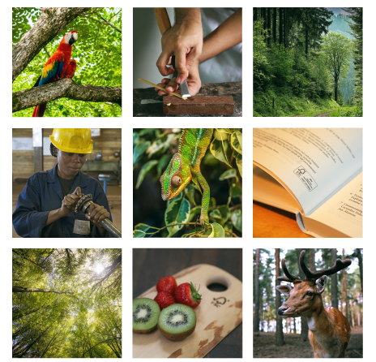
Contact

Damian Paull
Chief Executive Officer
FSC Australia and New Zealand

1/458 Swanston Street
Carlton, 3053, VIC

Phone: +61 3 9005 0907

Mobile: +61 427 181 880
E-Mail: d.paull@au.fsc.org

A written document that specifies the time by when the different Criteria from the applicable FSC standard will be implemented by the user of the CIP during the first certification cycle of each Management Unit.
To avoid conflicts of interest, FSC Australia, as the standard-setting body, cannot play a direct role in the certification process and cannot provide consultation regarding implementation of its standards. A consultant will consequently be engaged to take on the responsibilities FSC Australia cannot.
During all field trips across all phases of the project, each external stakeholder (consultant, IWG members, experts, FSC staff) will be paired with a Traditional Owner from the local community. The Traditional Owners will act as personal guides, interpreters, and mentors. In addition to providing necessary interpretation services, this pairing of external stakeholders and Traditional Owners will provide a two-way learning process where the external stakeholder gets access to an invaluable source of knowledge about local circumstances, while the broader community gains a deeper understanding of the project through the Traditional Owners’ interaction with the project team.
Being an independent audit, a positive outcome is not guaranteed, and it is possible that major non-conformances will be identified by the auditor. These major non-conformances must be closed before certification can be granted. There is money in the budget (see section VIII) to take remedial action to address identified non-conformances. This is also the case for the surveillance audits in Phase 8.

