INTERNATIONAL WOOD TRADE EVENT
“Boosting international trade in certified wood products from Indonesia”
25 – 26 January 2016

Hotel Majapahit  Jalan Tunjungan 65  60275 Surabaya, Indonesia  Phone: +62 31 5454 333  Contact  The Borneo Initiative  info@theborneoinitiative.org  USA: +1 571 306 8788  NL: +31 6 1066 5564  ID: +62 818 401 401 | 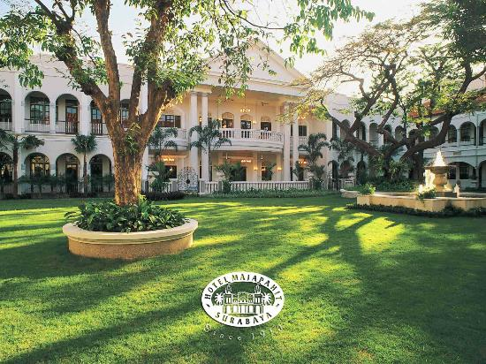

The International Wood Trade event provides you with access to forest concessions and forest industries involved in plywood, decking, flooring, moulding, and garden furniture in Indonesia. This event is free of charge. The following pages list most information you need to know to attend this event. If you have questions, please contact us.

Hotel
The International Wood Trade event will be held in Hotel Majapahit Surabaya.
Special room rate and benefits are offered for participants:
Executive Suite – IDR 1,250,000 net/room/night (+/- USD 90 net/room/night)
Benefits:
- Buffet breakfast at Indigo Restaurant
- Complimentary use of Health Club facilities
- Welcome drink upon arrival
- Free WiFi
*Hotel Majapahit uses UK plugs for electricity, although there is one continental connector per room (under the desk).

Travel information
Juanda International Airport is your flight destination. Hotel Majapahit Surabaya is 45 miles from Juanda International Airport. This is approximately a 50 minutes journey by car. Airport transfer is provided by Hotel Majapahit for IDR 300.000/net (USD 22).

Highlight Surabaya
Surabaya is Indonesia’s second largest city and the capital of East Java province. It is located on the northern shore of eastern Java at the mouth of the Mas River and along the edge of the Madura Strait. To some Indonesians, it is known as “the city of heroes” due to the importance of the Battle of Surabaya in galvanizing Indonesian and international support for Indonesian independence during the Indonesian National Revolution. Surabaya is also known as the birthplace of Indonesia’s first president, Ir. Soekarno.

Free Tourist Visa
By Presidential Decree of 9 June 2015, Indonesia now provides Free Tourist Visa to citizens of 45 countries effective 11 June 2015.

More information
http://www.indonesia.travel/en/travel-information

Registration form

OVERSEAS WOOD TRADING COMPANY - PROFILE

Company name

Office address

Sales contact person

Email address

Phone

Fax

Web address
Main business activities: | Import and distribution  Processing (please specify: __________________)  Retail  Other (please specify: _____________________)
Products of interest: | ☐ Round wood logs  ☐ Plywood  ☐ Sawn timber  ☐ Veneers (rotary and sliced)  ☐ Mouldings (please specify: __________________________)  ☐ Flooring  ☐ Decking  ☐ Furniture (indoor, outdoor. Please specify: _____________)  ☐ Doors  ☐ Other wood panel (please specify: ____________________)  ☐ Other (please specify: ______________________________)
Tropical hardwood species of interest: | ☐ Meranti  ☐ Dark red meranti  ☐ Keruing  ☐ Bangkirai  ☐ Merbau  ☐ Other (please specify: _____________________________)

Scale of operations Reference year:
Main products | Product type | Sales volume (cu.m/yr)

Top 5-destination markets (you can modify the table to suit your preference):
Country | 2012 | 2013
 | % | %

Short company profile:

The Borneo Initiative will publish your company information in a list of participants’ booklet that includes FSC® certified industries that participate in the event. The Borneo Initiative reserves the right to edit your company information if description is too long.

